AN EARLY START



LEARN TO CODE NOW!

AT PI HI, YOU CAN DEVELOP A PROFESSIONAL SKILLSET EARLY AND START COLLEGE AHEAD OF YOUR PEERS

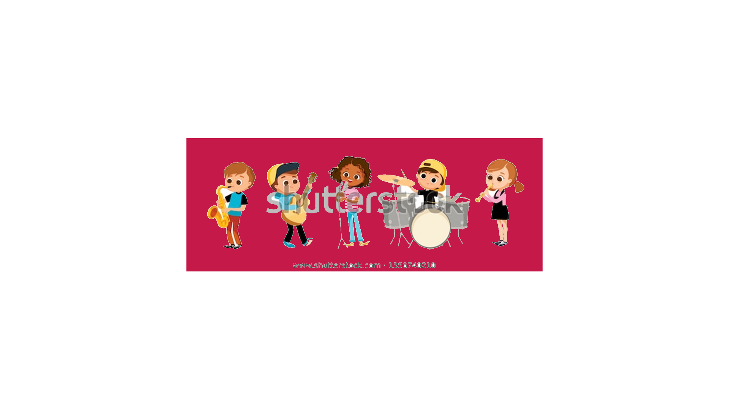

TELL THE WORLD WHO YOU ARE

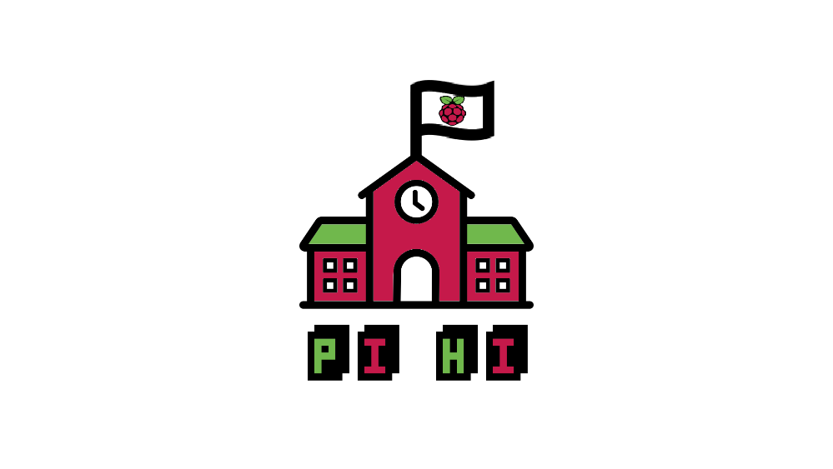

LEARN TO MAKE YOUR OWN WEBSITE TO TURN ANY INTEREST, ANY PASSION, INTO A CAREER. SHOW THE WORLD WHAT YOU CAN DO WITH PI HI

AFFORDABLE

ADAPTABLE

PORTABLE

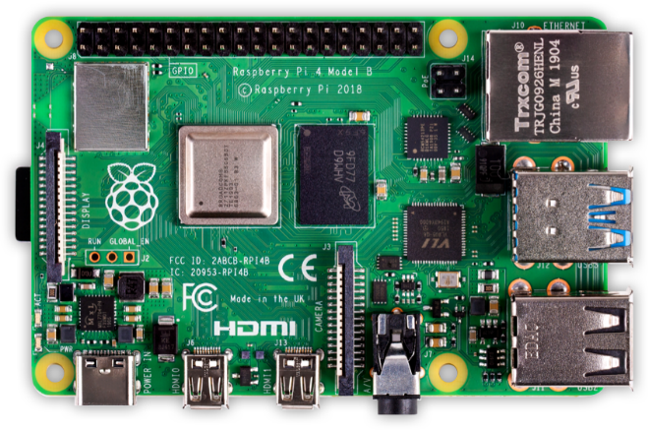

THE RASPBERRY PI MICROCOMPUTER MAKES IT SO ANYONE CAN BE A DEVELOPER.

THE MASSIVE OPENSOURCE COMMUNITY ALLOWS FOR ANYONE TO TAKE PART IN ANY NUMBER OF PROJECTS.

LINUX SUPPORT CAN TURN THIS WONDERFUL LITTLE DEVICE INTO A FULL-FLEDGED DESKTOP WEB DEVELOPMENT ENVIRONMENT.

JOIN US AFTER SCHOOL TO FIND OUT HOW YOU CAN BECOME A DEVELOPER NOW!

